**Project 1: Expense Reimbursement System**

**Executive Summary**

The Expense Reimbursement System (ERS) will manage the process of reimbursing employees for expenses incurred while on company time. All employees in the company can login and submit requests for reimbursement and view their past tickets and pending requests. Finance managers can log in and view all reimbursement requests and past history for all employees in the company. Finance managers are authorized to approve and deny requests for expense reimbursement.

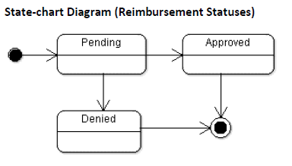

**Reimbursement Types**

Employees must select the type of reimbursement as: LODGING, TRAVEL, FOOD, or OTHER.

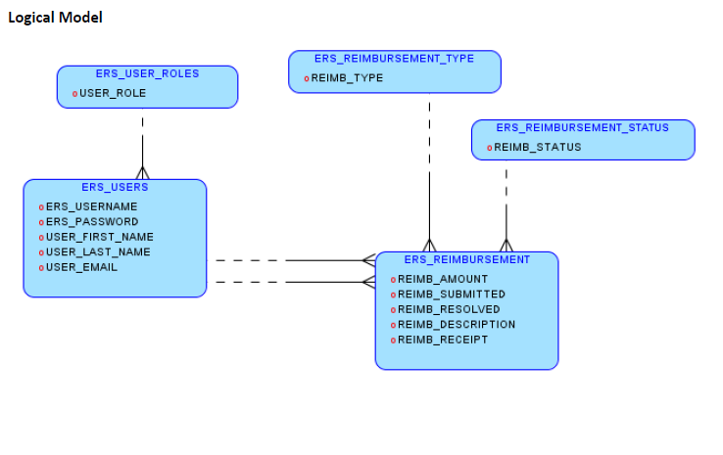

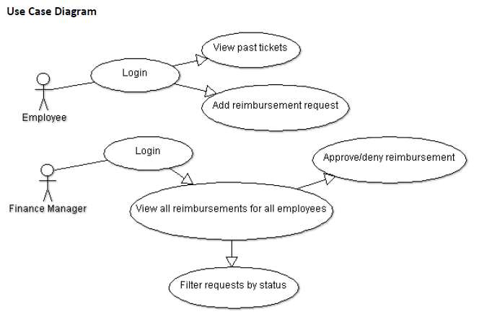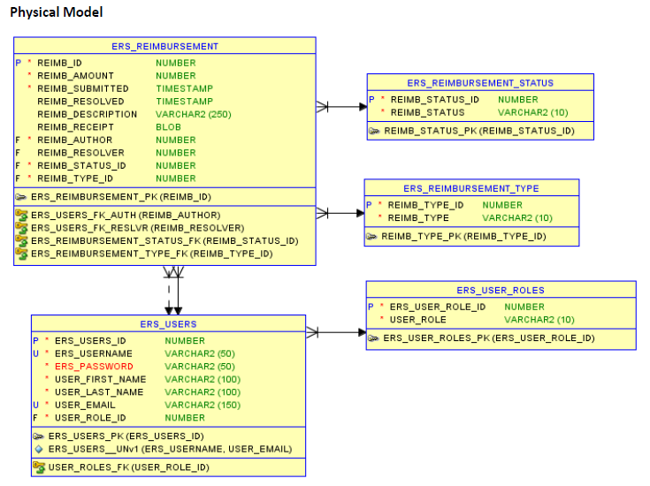

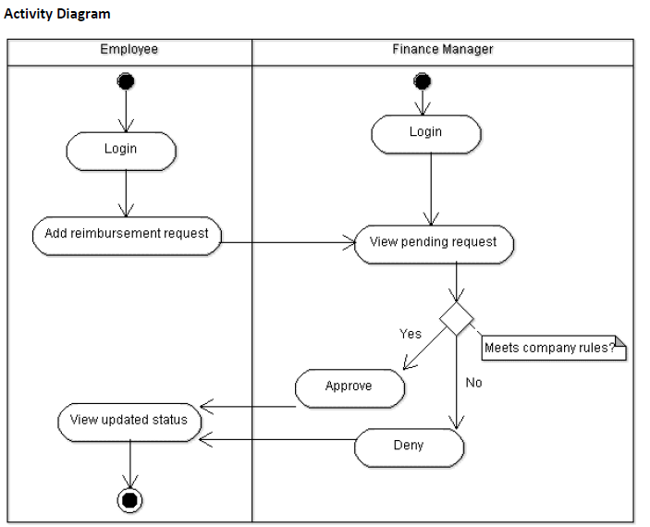

**Technical Requirements**

* The application shall employ the DAO design pattern, and properly separate your code into the appropriate layers
* The back-end system shall use JDBC to connect to an Oracle 12 EE database.
  + Use at least one of our three statements – Statement, PreparedStatement, and CallableStatement
* The application shall deploy onto a Tomcat Server
* The middle tier shall use Servlet technology for dynamic Web application development
* The front-end view can use JavaScript and AJAX to call server-side components. The web pages should look presentable (use css and bootstrap)
* Use Log4J
* Unit tests to be done in jUnit and Postman
* Passwords shall be encrypted (optional) in Java and securely stored in the database
* Users can upload a document or image of their receipt when submitting reimbursements(optional)
* The application will send an email to employees letting them know that they have been registered as a new user, giving them their temporary password (optional)

**Dates**

* 03/20/19 start: project 1 specs released
* 04/03/19 completion: project 1 presentations

**Please take the deadline seriously, the presentation date will NOT be moved.

**Do NOT spend too much time stuck on a single blocker without asking a batch-mate for help.

**Lastly, setting up your database shouldn’t take very long (a few days max); and if one third of the time has passed (Thursday 03/28/18 ish) and you have not completed at least the login functionality then you may want to pick up the pace.